**EXCEL ASSIGNMENT - 15**

**Dataset:**

**https://docs.google.com/spreadsheets/d/1IRSEnmgz8Ro276-**

**GslknRNk0zlrB5CZH1YrnT71kqFM/edit?usp=sharing**

**Use the above dataset and answer the following questions.**

**1. Create a Pivot table and show what the main export product is?**

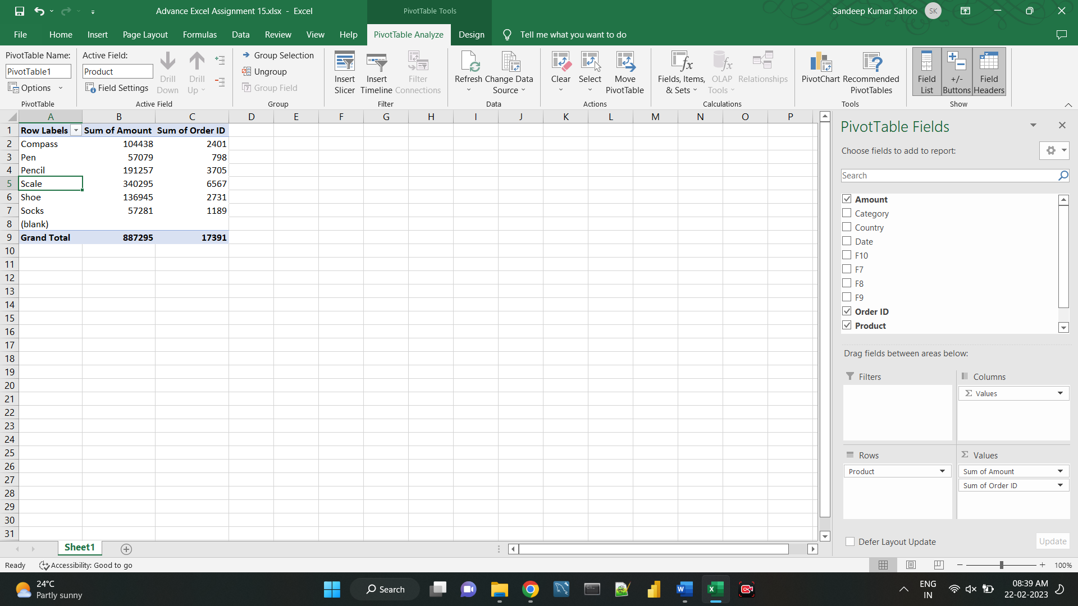

**2. Create a bar graph showing the amount spent for each product?**

**3. Create a Pivot table to show the sales in each city**

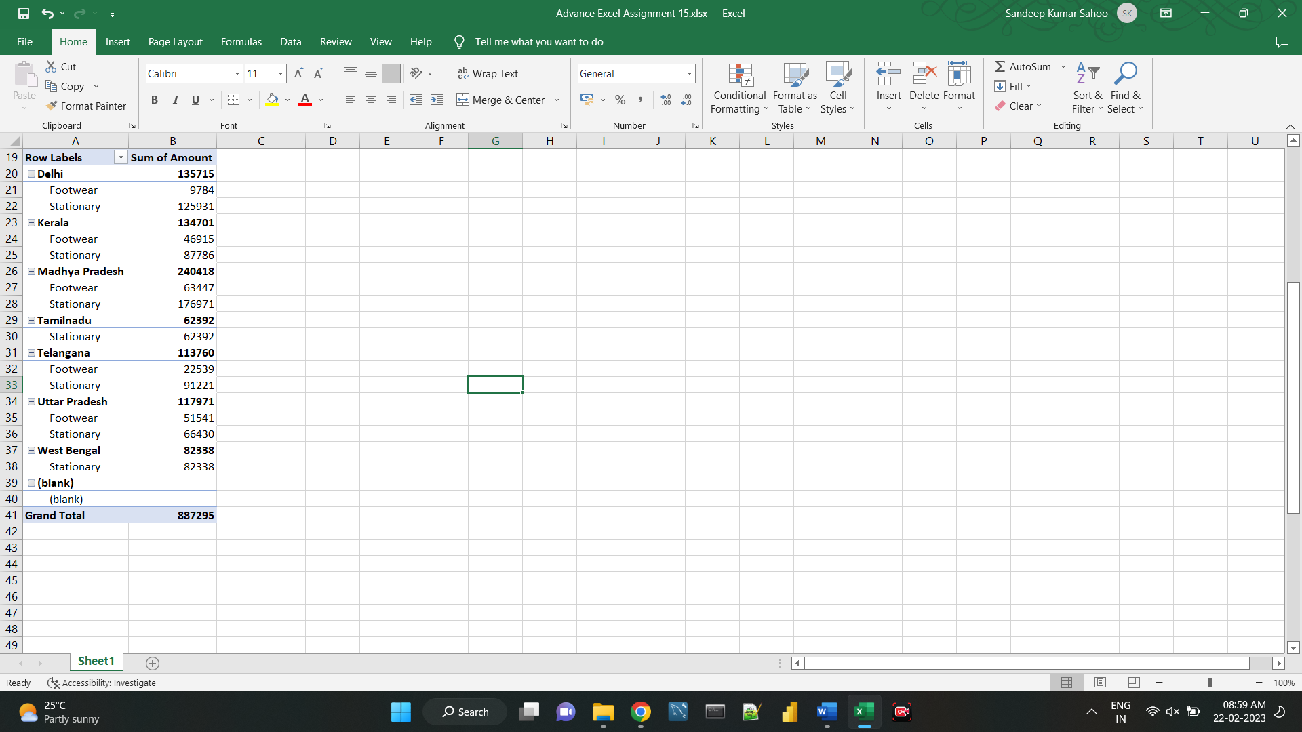

**4. Create a chart showing the amount spent for each product in each city.**

